**PROGRAM1:FINDS**

**AIM:**

**Implement and demonstrate the FINDS algorithm for finding the  most specific hypothesis based on a given set of training data samples. Read the training data from a .CSV file**

**PROGRAM:**

import csv

a = []

with open('enjoysport.csv', 'r') as csvfile:

for row in csv.reader(csvfile):

a.append(row)

print(a)

print("\n The total number of training instances are : ",len(a))

num_attribute = len(a[0])-1

print("\n The initial hypothesis is : ")

hypothesis = ['0']*num_attribute

print(hypothesis)

for i in range(0, len(a)):

if a[i][num_attribute] == 'yes':

for j in range(0, num_attribute):

if hypothesis[j] == '0' or hypothesis[j] == a[i][j]:

hypothesis[j] = a[i][j]

else:

hypothesis[j] = '?'

print("\n The hypothesis for the training instance {} is :\n" .format(i+1),hypothesis)

print("\n The Maximally specific hypothesis for the training instance is ")

print(hypothesis)

**RESULT**

[['sky', 'airtemp', 'humidity', 'wind', 'water', 'forcast', 'enjoysport'], ['sunny', 'warm', 'normal', 'strong', 'warm', 'same', 'yes'], ['sunny', 'warm', 'high', 'strong', 'warm', 'same', 'yes'], ['rainy', 'cold', 'high', 'strong', 'warm', 'change', 'no'], ['sunny', 'warm', 'high', 'strong', 'cool', 'change', 'yes']]

The total number of training instances are : 5

The initial hypothesis is :

['0', '0', '0', '0', '0', '0']

The hypothesis for the training instance 1 is :

['0', '0', '0', '0', '0', '0']

The hypothesis for the training instance 2 is :

['sunny', 'warm', 'normal', 'strong', 'warm', 'same']

The hypothesis for the training instance 3 is :

['sunny', 'warm', '?', 'strong', 'warm', 'same']

The hypothesis for the training instance 4 is :

['sunny', 'warm', '?', 'strong', 'warm', 'same']

The hypothesis for the training instance 5 is :

['sunny', 'warm', '?', 'strong', '?', '?']

The Maximally specific hypothesis for the training instance is

['sunny', 'warm', '?', 'strong', '?', '?']

**PROGRAM:2 CE ALGORITHM**

**AIM: For a given set of training data examples stored in a .CSV file, implement and demonstrate the Candidate-Elimination algorithm in python to output a description of the set of all hypotheses consistent with the training examples.**

import numpy as np

import pandas as pd

data = pd.read_csv('D:/GEO/BE COURSES/2022 dec/LAB/DATASET/enjoysport.csv')

concepts = np.array(data.iloc[:,0:-1])

print("\nInstances are:\n",concepts)

target = np.array(data.iloc[:,-1])

print("\nTarget Values are: ",target)

def learn(concepts, target):

specific_h = concepts[0].copy()

print("\nInitialization of specific_h and genearal_h")

print("\nSpecific Boundary: ", specific_h)

general_h = [["?" for i in range(len(specific_h))] for i in range(len(specific_h))]

print("\nGeneric Boundary: ",general_h)

for i, h in enumerate(concepts):

print("\nInstance", i+1 , "is ", h)

if target[i] == "yes":

print("Instance is Positive ")

for x in range(len(specific_h)):

if h[x]!= specific_h[x]:

specific_h[x] ='?'

general_h[x][x] ='?'

if target[i] == "no":

print("Instance is Negative ")

for x in range(len(specific_h)):

if h[x]!= specific_h[x]:

general_h[x][x] = specific_h[x]

else:

general_h[x][x] = '?'

print("Specific Bundary after ", i+1, "Instance is ", specific_h)

print("Generic Boundary after ", i+1, "Instance is ", general_h)

print("\n")

**RESULT:**

Instances are:

[['sunny' 'warm' 'normal' 'strong' 'warm' 'same']

['sunny' 'warm' 'high' 'strong' 'warm' 'same']

['rainy' 'cold' 'high' 'strong' 'warm' 'change']

['sunny' 'warm' 'high' 'strong' 'cool' 'change']]

Target Values are: ['yes' 'yes' 'no' 'yes']

**PROGRAM :3 DECISION TREE**

**AIM: Write a program to demonstrate the working of the decision tree based ID3 algorithm. Use an appropriate data set for building the decision tree and apply this knowledge to classify a new sample.**

@author: GEOMOL GEORGE

"""

#Import Libraries

import matplotlib.pyplot as plt

from sklearn.datasets import load_iris

#from sklearn.datasets import load_breast_cancer

from sklearn.tree import DecisionTreeClassifier

#from sklearn.ensemble import RandomForestClassifier

from sklearn.model_selection import train_test_split

import pandas as pd

import numpy as np

from sklearn import tree

#Load the Dataset

import pandas as pd

from sklearn.datasets import load_iris

data = load_iris()

#data= pd.read_csv("D:/GEO/BE COURSES/LAB/DATASET/pima-indians-diabetes.csv")

df = pd.DataFrame(data.data, columns=data.feature_names)

df['target'] = data.target

#Splitting Data into Training and Test Sets

X_train, X_test, Y_train, Y_test = train_test_split(df[data.feature_names], df['target'], random_state=0)

#Scikit-learn 4-Step Modeling Pattern

# Step 1: Import the model you want to use

# This was already imported earlier in the notebook so commenting out

#from sklearn.tree import DecisionTreeClassifier

# Step 2: Make an instance of the Model

clf = DecisionTreeClassifier(max_depth = 2,random_state = 0)

# Step 3: Train the model on the data

clf.fit(X_train, Y_train)

# Step 4: Predict labels of unseen (test) data

# Not doing this step in the tutorial

# clf.predict(X_test)

#How to Visualize Decision Trees using Matplotlib

tree.plot_tree(clf);

fn=['sepal length (cm)','sepal width (cm)','petal length (cm)','petal width (cm)']

cn=['setosa', 'versicolor', 'virginica']

fig, axes = plt.subplots(nrows = 1,ncols = 1,figsize = (4,4), dpi=300)

tree.plot_tree(clf,

feature_names = fn,

class_names=cn,

filled = True);

fig.savefig('imagename.png')

**RESULT:**

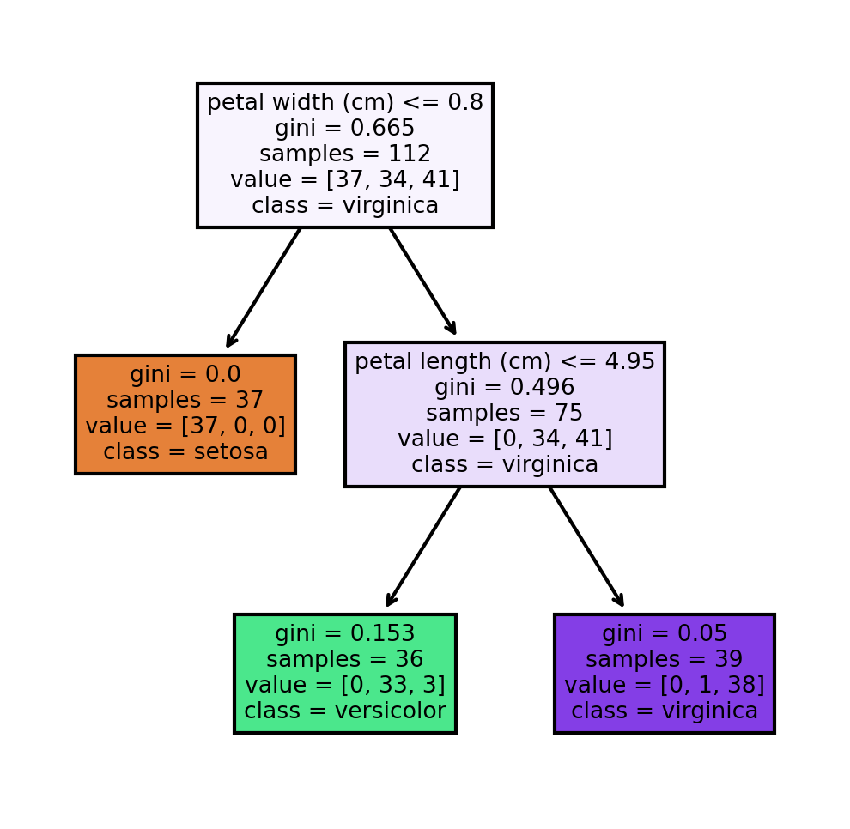

**PROGRAM4:BACK PROPAGATION**

AIM: Build an Artificial Neural Network by implementing the Backpropagation algorithm and test the same using appropriate data sets.

import numpy as np

X = np.array(([2, 9], [1, 5], [3, 6]), dtype=float)

y = np.array(([92], [86], [89]), dtype=float)

X = X/np.amax(X,axis=0) #maximum of X array longitudinally

y = y/100

#Sigmoid Function

def sigmoid (x):

return 1/(1 + np.exp(-x))

#Derivative of Sigmoid Function

def derivatives_sigmoid(x):

return x * (1 - x)

#Variable initialization

epoch=5 #Setting training iterations

lr=0.1 #Setting learning rate

inputlayer_neurons = 2 #number of features in data set

hiddenlayer_neurons = 3 #number of hidden layers neurons

output_neurons = 1 #number of neurons at output layer

#weight and bias initialization

wh=np.random.uniform(size=(inputlayer_neurons,hiddenlayer_neurons))

bh=np.random.uniform(size=(1,hiddenlayer_neurons))

wout=np.random.uniform(size=(hiddenlayer_neurons,output_neurons))

bout=np.random.uniform(size=(1,output_neurons))

#draws a random range of numbers uniformly of dim x*y

for i in range(epoch):

#Forward Propogation

hinp1=np.dot(X,wh)

hinp=hinp1 + bh

hlayer_act = sigmoid(hinp)

outinp1=np.dot(hlayer_act,wout)

outinp= outinp1+bout

output = sigmoid(outinp)

#Backpropagation

EO = y-output

outgrad = derivatives_sigmoid(output)

d_output = EO * outgrad

EH = d_output.dot(wout.T)

hiddengrad = derivatives_sigmoid(hlayer_act)#how much hidden layer wts contributed to error

d_hiddenlayer = EH * hiddengrad

wout += hlayer_act.T.dot(d_output) *lr # dotproduct of nextlayererror and currentlayerop

wh += X.T.dot(d_hiddenlayer) *lr

print ("-----------Epoch-", i+1, "Starts----------")

print("Input: \n" + str(X))

print("Actual Output: \n" + str(y))

print("Predicted Output: \n" ,output)

print ("-----------Epoch-", i+1, "Ends----------\n")

print("Input: \n" + str(X))

print("Actual Output: \n" + str(y))

print("Predicted Output: \n" ,output)

**RESULT:**

**Input:**

**[[0.66666667 1. ]**

**[0.33333333 0.55555556]**

**[1. 0.66666667]]**

**Actual Output:**

**[[0.92]**

**[0.86]**

**[0.89]]**

**Predicted Output:**

**[[0.85680382]**

**[0.83717506]**

**[0.86055174]]**

**-----------Epoch- 3 Ends----------**

**-----------Epoch- 4 Starts----------**

**Input:**

**[[0.66666667 1. ]**

**[0.33333333 0.55555556]**

**[1. 0.66666667]]**

**Actual Output:**

**[[0.92]**

**[0.86]**

**[0.89]]**

**Predicted Output:**

**[[0.85716867]**

**[0.83754295]**

**[0.86091463]]**

**-----------Epoch- 4 Ends----------**

**-----------Epoch- 5 Starts----------**

**Input:**

**[[0.66666667 1. ]**

**[0.33333333 0.55555556]**

**[1. 0.66666667]]**

**Actual Output:**

**[[0.92]**

**[0.86]**

**[0.89]]**

**Predicted Output:**

**[[0.85752859]**

**[0.83790597]**

**[0.86127258]]**

**-----------Epoch- 5 Ends----------**

**Input:**

**[[0.66666667 1. ]**

**[0.33333333 0.55555556]**

**[1. 0.66666667]]**

**Actual Output:**

**[[0.92]**

**[0.86]**

**[0.89]]**

**Predicted Output:**

**[[0.85752859]**

**[0.83790597]**

**[0.86127258]]**

**PROGRAM5: CLASSIFICATION OF IRIS (IN-BUILT) USING KNN**

AIM: **Write a program for Implementation of K-Nearest Neighbors (K-NN) in Python**

from sklearn.model_selection import train_test_split

from sklearn.neighbors import KNeighborsClassifier

from sklearn.metrics import classification_report, confusion_matrix

from sklearn import datasets

iris=datasets.load_iris()

x = iris.data

y = iris.target

print ('sepal-length', 'sepal-width', 'petal-length', 'petal-width')

print(x)

print('class: 0-Iris-Setosa, 1- Iris-Versicolour, 2- Iris-Virginica')

print(y)

x_train, x_test, y_train, y_test = train_test_split(x,y,test_size=0.3)

#To Training the model and Nearest nighbors K=5

classifier = KNeighborsClassifier(n_neighbors=5)

classifier.fit(x_train, y_train)

#To make predictions on our test data

y_pred=classifier.predict(x_test)

print('Confusion Matrix')

print(confusion_matrix(y_test,y_pred))

print(' classification_report)

print(classification_report(y_test,y_pred))

**RESULT**

**Confusion Matrix**

**[[17 0 0]**

**[ 0 10 1]**

**[ 0 3 14]]**

**classification_report**

**precision recall f1-score support**

**0 1.00 1.00 1.00 17**

**1 0.77 0.91 0.83 11**

**2 0.93 0.82 0.87 17**

**accuracy 0.91 45**

**macro avg 0.90 0.91 0.90 45**

**weighted avg 0.92 0.91 0.91 45**

**Accuracy Score: 0.9111111111111111**

**PROGRAM 6: NAÏVE BAYES**

**AIM: Write a program to implement Naïve Bayes algorithm in python and to display the results using confusion matrix and accuracy. Java/Python ML library classes can be used for this problem.**

import numpy as np

import pandas as pd

#Importing the dataset

dataset = pd.read_csv("breastcancer.csv")

X = dataset.iloc[:, :-1].values

y = dataset.iloc[:, -1].values

from sklearn.model_selection import train_test_split

X_train, X_test, y_train, y_test = train_test_split(X, y, test_size = 0.25, random_state = 0)

from sklearn.preprocessing import StandardScaler

sc = StandardScaler()

X_train = sc.fit_transform(X_train)

X_test = sc.transform(X_test)

from sklearn.naive_bayes import GaussianNB

classifier = GaussianNB()

classifier.fit(X_train, y_train)

#Naive Bayes classifier model

GaussianNB(priors=None, var_smoothing=1e-09)

#Display the results (confusion matrix and accuracy)

from sklearn.metrics import confusion_matrix, accuracy_score

y_pred = classifier.predict(X_test)

cm = confusion_matrix(y_test, y_pred)

print(cm)

accuracy_score(y_test, y_pred)

**RESULT:**

**[[99 8]**

**[ 2 62]]**

**PROGRAM :7-LINEAR REGRESSION**

AIM:Write a program to implement Linear Regression (LR) algorithm in python

import pandas as pd

from sklearn.model_selection import train_test_split

from sklearn.linear_model import LinearRegression

from sklearn.metrics import mean_squared_error

import matplotlib.pyplot as plt

# Load the dataset

dataset = pd.read_csv('Salary_Data.csv')

# Split the dataset into independent variables (X) and dependent variable (y)

X = dataset.iloc[:, :-1].values

y = dataset.iloc[:, -1].values

# Split the dataset into training and testing sets

X_train, X_test, y_train, y_test = train_test_split(X, y, test_size=0.2, random_state=42)

# Create an instance of the Linear Regression model

model = LinearRegression()

# Fit the model to the training data

model.fit(X_train, y_train)

# Predict the salaries for the test data

y_pred = model.predict(X_test)

#model good or not

mse = mean_squared_error(y_test, y_pred)

print("Mean Squared Error:", mse)

#Visualising the Training set results Here scatter plot is used to visualize the results.

plt.scatter(X_train, y_train, color = 'red')

plt.plot(X_train, model.predict(X_train), color = 'blue')

plt.title('Salary vs Experience (Training set)')

plt.xlabel('Years of Experience')

plt.ylabel('Salary')

plt.show()

**RESULT**

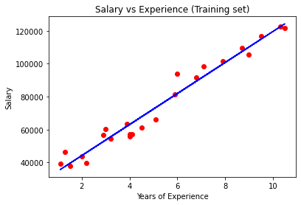

**PROGRAM:8 LOGISTIC REGRESSION (Brestcancerdataset)**

**AIM: Write a program to implement Logistic Regression (LR) algorithm in python**

import numpy as np

import pandas as pd

#"Importing the dataset

# divide the dataset into concepts and targets. Store the concepts into X and targets into y.

dataset = pd.read_csv("D:/GEO/BE COURSES/2022 dec/LAB/DATASET/breastcancer.csv")

X = dataset.iloc[:, :-1].values

y = dataset.iloc[:, -1].values

#Splitting the dataset into the Training set and Test

from sklearn.model_selection import train_test_split

X_train, X_test, y_train, y_test = train_test_split(X, y, test_size = 0.30, random_state = 2)

#Feature Scaling

from sklearn.preprocessing import StandardScaler

sc = StandardScaler()

X_train = sc.fit_transform(X_train)

X_test = sc.transform(X_test)

from sklearn.linear_model import LogisticRegression

classifier = LogisticRegression(random_state = 0)

classifier.fit(X_train, y_train)

#Logistic Regression (LR) classifier model

#Display the results (confusion matrix and accuracy)

from sklearn.metrics import confusion_matrix, accuracy_score

y_pred = classifier.predict(X_test)

cm = confusion_matrix(y_test, y_pred)

print(cm)

print('Accuracy Score:confusion matrix')

accuracy_score(y_test, y_pred)

# Calculate the accuracy of the model

accuracy = accuracy_score(y_test, y_pred)

print("Accuracy:", accuracy)

**RESULT**

**[[117 8]**

**[ 6 74]]**

**Accuracy Score:confusion matrix**

**Accuracy: 0.9317073170731708**

**PROGRAM 8 POLYNOMIAL REGRESSION**

AIM: **Implementation Of Linear And Polynomial Regression In Python**

import numpy as np

import matplotlib.pyplot as plt

import pandas as pd

dataset = pd.read_csv('Position_Salaries.csv')

X = dataset.iloc[:, 1:-1].values

y = dataset.iloc[:, -1].values

from sklearn.linear_model import LinearRegression

lin_reg = LinearRegression()

lin_reg.fit(X, y)

#Linear Regression classifier model

#(copy_X=True, fit_intercept=True, n_jobs=None, normalize=False)

from sklearn.preprocessing import PolynomialFeatures

poly_reg = PolynomialFeatures(degree = 4)

X_poly = poly_reg.fit_transform(X)

lin_reg_2 = LinearRegression()

lin_reg_2.fit(X_poly, y)

#Polynomial Regression classifier model

#LinearRegression(copy_X=True, fit_intercept=True, n_jobs=None, normalize=False)

plt.scatter(X, y, color = 'red')

plt.plot(X, lin_reg.predict(X), color = 'blue')

plt.title('Truth or Bluff (Linear Regression)')

plt.xlabel('Position Level')

plt.ylabel('Salary')

plt.show()

#Visualising the Polynomial Regression results

plt.scatter(X, y, color = 'red')

plt.plot(X, lin_reg_2.predict(poly_reg.fit_transform(X)), color = 'blue')

plt.title('Truth or Bluff (Polynomial Regression)')

plt.xlabel('Position level')

plt.ylabel('Salary')

plt.show()

**RESULT**

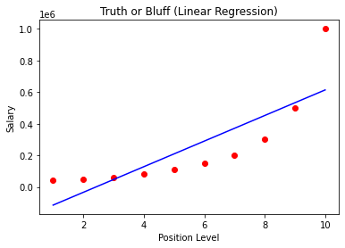

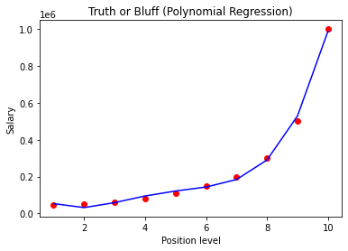

**PROGRAM9 EM algorithm**

**AIM: Python Program to Implement Estimation & MAximization Algorithm**

from sklearn.mixture import GaussianMixture

import sklearn.metrics as metrics

import pandas as pd

import numpy as np

import matplotlib.pyplot as plt

# Read the dataset

dataset = pd.read_csv("D:/GEO/BE COURSES/2022 dec/LAB/IRIS.csv")

X = dataset.iloc[:, :-1]

label = {'Iris-setosa': 0, 'Iris-versicolor': 1, 'Iris-virginica': 2}

y = dataset.iloc[:, -1].map(label) # Convert class labels to integer values

plt.figure(figsize=(14, 7))

colormap = np.array(['red', 'lime', 'black'])

# REAL PLOT

plt.subplot(1, 3, 1)

plt.title('Real')

plt.scatter(X.petal_length, X.petal_width, c=colormap[y]) # Use y as the class indices

gmm = GaussianMixture(n_components=3, random_state=0).fit(X)

y_cluster_gmm = gmm.predict(X)

# GMM Classification PLOT

plt.subplot(1, 3, 3)

plt.title('GMM Classification')

plt.scatter(X.petal_length, X.petal_width, c=colormap[y_cluster_gmm]) # Use y_cluster_gmm for colors

# Print metrics

print('The accuracy score of GMM:', metrics.accuracy_score(y, y_cluster_gmm))

print('The Confusion matrix of GMM:\n', metrics.confusion_matrix(y, y_cluster_gmm))

plt.tight_layout()

plt.show()

RESULT:

The accuracy score of GMM: 0.36666666666666664

The Confusion matrix of GMM:

[[50 0 0]

[ 0 5 45]

[ 0 50 0]]

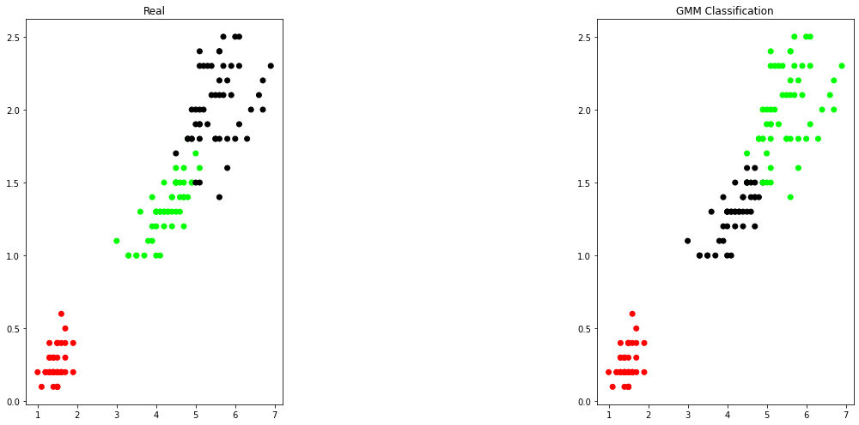

**PROGRAM 10:PERCEPTRON IRIS CLASSIFCATION**

AIM:Write python code for PERCEPTRON IRIS CLASSIFCATION

from sklearn import datasets

import numpy as np

from sklearn.model_selection import train_test_split

from sklearn.linear_model import Perceptron

from sklearn.preprocessing import StandardScaler

from sklearn.metrics import accuracy_score

iris = datasets.load_iris()

X = iris.data[:, [2, 3]]

y = iris.target

X_train, X_test, y_train, y_test = train_test_split(

X, y, test_size=0.3, random_state=1, stratify=y)

sc = StandardScaler()

sc.fit(X_train)

X_train_std = sc.transform(X_train)

X_test_std = sc.transform(X_test)

ppn = Perceptron(eta0=0.1, random_state=1)

ppn.fit(X_train_std, y_train)

y_pred = ppn.predict(X_test_std)

print('Accuracy:' % accuracy_score(y_test, y_pred))

**RESULT**

**Accuracy:**

**perceptron IRIS classification Accuracy: 0.978**